My Target: ____ / 40 or ______ % Complete on the day of the test

🖒 🖓 (Circle when your test is handed back)

**Name: __ Teacher:**



Yr 9 Humanities & Social Sciences:

*The Making of the Modern World*

|  |  |  |
| --- | --- | --- |
| Total marks  **/40** | **%** | **Weight**  **15%** |
|  |  |  |

***Task Five:***

***“A Soldier’s Story”***

***A Short Report Assessment***

Part 1:

You have chosen an article about a WWI soldier. ( from the list your teacher has) You must read the article and then take notes from the article using the note taking sheet provided.

**Rules for taking notes:**

**What to take:**

* Main ideas only
* Key words
* Use generic terms
* Use abbreviation and signs
* Use organisation to create an order

**What to leave:**

* Functional words – like, the, as etc.
* Opinions and decorating expressions
* Examples

Part 2:

* Now you must choose you own soldier from WWI, this can be a relative if you wish.
* Take notes about your soldier as you did for part 1.
* Then write a Newspaper article about your soldier, like the one you were given for part 1.

You will find the Australian War Memorial site useful for this.

[**Australian War Memorial: Home**](https://www.awm.gov.au/)[*https://www.awm.gov.au/*](https://www.awm.gov.au/) *- search for a person.*

**Rules for writing a newspaper article:**

1. **Compile all your facts.** Before you write a news article, make a list or outline of all the pertinent facts and information that need to be included in the article. This fact list will help prevent you from leaving out any relevant information about the topic or story and will also help you write a clean, succinct article. **You will get this information from your notes.**

**2. Start with your lead.** News articles begin with a leading sentence that is meant to grab a reader's attention and interest them. This is one of the most important parts of the piece, so start with the leading statement when writing a news article. Your lead should be one sentence and should simply, but completely, state the topic of the article

1. **Give all the important details.** The next important step to writing

News articles are including all the relevant facts and details that relate to your lead statement. Include the basics of what happened, where and when it took place, who is involved and why it's newsworthy. These details are important, because they are the focal point of the article that fully informs the reader.

1. **Follow up main facts with additional information.** After you've

listed all the primary facts in your news article, include any additional information that might help the reader learn more, such as contact information, additional facts about the topic or people involved, or quotes from interviews. This additional information helps round out the article.

1. **Check facts before concluding.** Be sure to double check all the

facts in your news article before you submit it, including names, dates, and contact information or addresses.

1. **Remain unbiased.** A news article is meant to convey direct facts,

not the opinions of its writer. Keep your writing unbiased and objective. Avoid any language that is overly positive or negative or statements that could be construed as support or criticism.

1. **Conclude your article.** Make sure your news article is complete

and finished by giving it a good concluding sentence. This is often a restatement of the leading statement or a statement indicating potential future developments relating to the article topic.

Below is an Inverted Pyramid which will help you with setting out your own article.

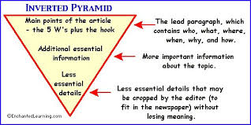

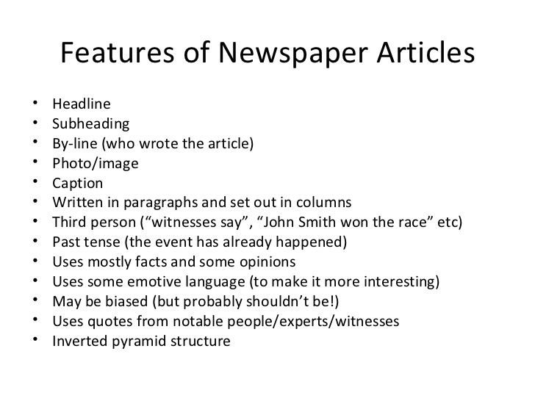

Marking Key

Yr 9 Society & Environment

The Making of the Modern World

“ A Soldier’s Story”

Mark / 40 Weighting 20%

|  |  |  |  |  |  |
| --- | --- | --- | --- | --- | --- |
|  | 1 | 2 | 3 | 4 | 5 |
| Notes from the article provided |  |  |  |  |  |
| Main ideas only |  |  |  |  |  |
| Key words used |  |  |  |  |  |
| Used generic terms |  |  |  |  |  |
| Used abbreviation and signs |  |  |  |  |  |
| Used organisation to create order |  |  |  |  |  |
| Notes from your own soldier |  |  |  |  |  |
| Main ideas only |  |  |  |  |  |
| Key words used |  |  |  |  |  |
| Used generic terms |  |  |  |  |  |
| Used abbreviation and signs |  |  |  |  |  |
| Used organisation to create order |  |  |  |  |  |
| Article written |  |  |  |  |  |
| Has followed the Inverted Pyramid design |  |  |  |  |  |
| Headline done |  |  |  |  |  |
| Subheadine done |  |  |  |  |  |
| Byline done |  |  |  |  |  |
| Dateline done |  |  |  |  |  |
| Photo or image included |  |  |  |  |  |
| Information in the articles is interesting |  |  |  |  |  |
| Information in the article is factual and well researched |  |  |  |  |  |
| Bibliography included |  |  |  |  |  |

Teachers comments.